Mountaineer Wrestling Camp
This camp features clinician Joe Kemmerer
- High School Record of 101-7
- Undefeated Pennsylvania AAA State Champion 2004, Crestwood
- Dapper Dan PA All-Star Team Member, 2004
- Collegiate Record of 91-11
- 2x NCAA D2 Champion 2007-2009 Kutztown University
- N.W.C.A. Outstanding Wrestler Award at 2009 Championships
- P.S.A.C. Champion 2009, Kutztown University (First for KU since 1942)
- Greco-Roman University National Champion 2010, Akron Ohio
- Greco-Roman University World Team Member 2010, Torino Italy
- Coached Div 1 Liberty University 2009-10, 2010-11
- Coached Div 1 Virginia Military Institute 2011-2012
- Clinician and Group Leader at Ken Chertow's Gold Medal Training Camp 2008-Current
- Kutztown University Athletics Hall of Fame Member
- Founder and Head Coach of HAMMER WRESTLING located in Morristown TN

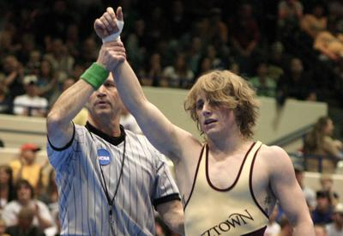

Cost- $100 for Camp if preregistered by May 1st ($110 after) (upcoming 6th-12th)
Siblings $75 apiece
Make checks to Tuscola High School.
Where- Central Elementary in Waynesville
When- June 15-17 Friday- Sunday
Friday-Registration 4:30pm-5pm 1st Session 5pm-9pm
Saturday- 2nd Session 9am-noon, lunch(noon-1pm), 3rd session 1pm-4pm
Sunday- 4th session 11am-1pm, break (1pm-2pm), 5th session 2pm-5pm
(If your church service goes past 11am you can skip the 4th session)

Lunch- pizza & drinks will be available for campers to purchase.

Questions?
Tuscola Wrestling Coach Austin Reece
areece@haywood.k12.nc.us
Cell- 828-230-9692
Mountaineer Wrestling Camp Pre- Registration
Friday 4:30pm-9pm
Saturday 9am-4pm
Sunday 11am-5pm
- Camp preregistration $100

Parent/Guardian name_______________________________
Parent phone #_____________________________________
Athlete name_______________________________________
Athlete shirt size_______

Please attach a check made to Tuscola High School and mail to

Tuscola High School Attn: Austin Reece
564 Tuscola School Rd
Waynesville NC 28786

Questions contact Coach Reece
cell-828-230-9692
email-areece@haywood.k12.nc.us

